- Go to the main menu
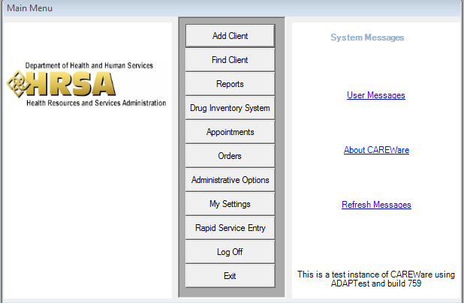
- Click Rapid Service Entry
- Click Group Service Entry
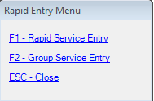
- Select an As of Date or check off Do not supply a date
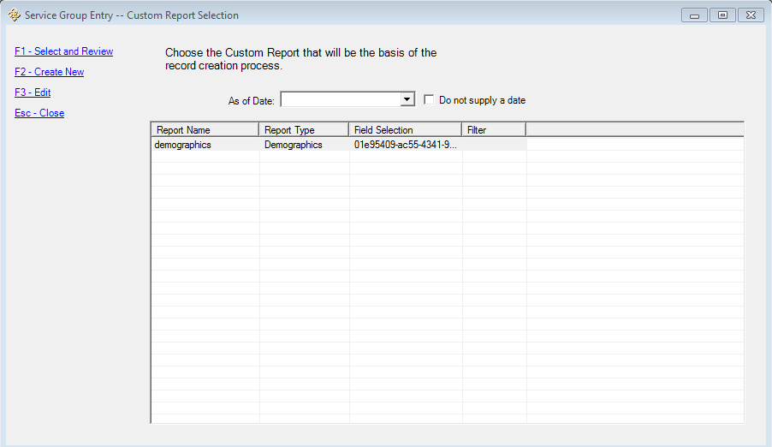
- Click Create New (This selection brings up a custom report window)
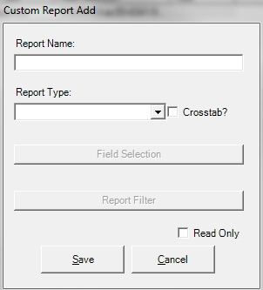
- Complete the custom report to select the group of clients you want to add services to (E.g., If you only wanted male, HIV positive clients, with case management services for instance)
- Click Save when you are finished defining the custom report
- Highlight the report
- Click Select and Review (You can also click Edit, if you need to go back and make changes to the custom report)
- The next window has a list of clients who are results of the custom report
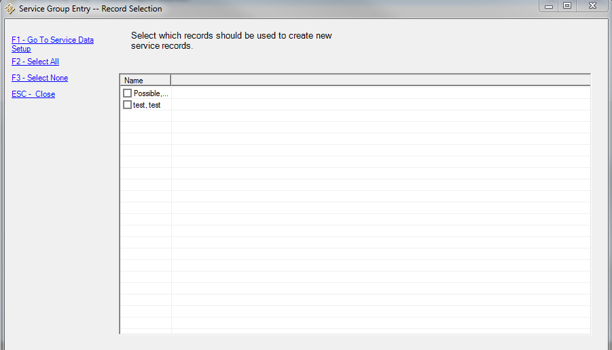
- Check the box next to each client that received the service to be added (Select All will check all boxes and Select None will remove all checks on boxes)
- Click Go To Service Data (This brings up a window to choose the service they received)
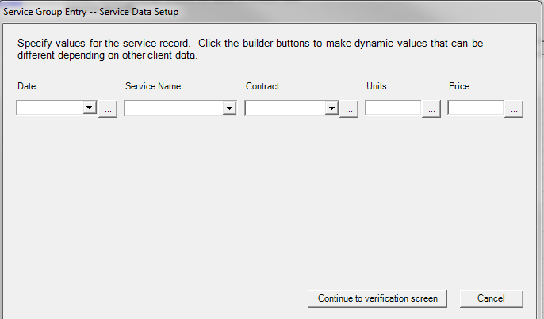
- Select a date for the service, the name of the service, The contract the service is under, how many units, and the price
- Click Continue to verification screen
- The next screen allows for you to see the services that will be added
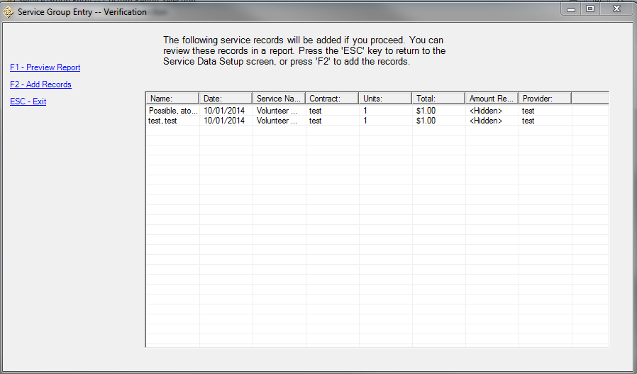
- To add the records: click Add Records (Preview Report will produce the custom report showing the records to be added)
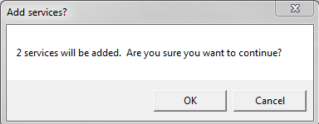
- When you are asked, Are you are sure you want to continue, click ok

