WICY Report Instructions
Rev 1.0 – updated 11/12/2014

The WICY Report in CAREWare has two main components – the main data entry form (called Expenditure Report Setup) and the report itself. The basic idea is that a user will enter the amounts allocated for each service category on the Expenditure Report Setup screen. These entered amounts will then be used in conjunction with the service data that CAREWare has stored in order to populate the WICY Report.

Note: To access and run the WICY report, the user must have the permissions ‘WICY Report Management’. This is found under the Central Admin domain in the Reports permission section.

Functional Overview

To get to the WICY Report, you must be logged in as a Central Administrator. From the main menu, choose Reports > WICY Report. This will take you to the first WICY Report form:

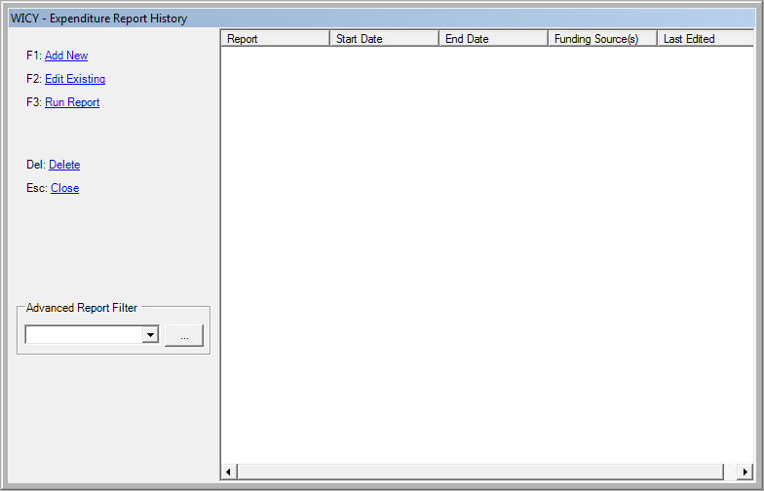
Create a new WICY Report setup.

Allows application of an additional filter to the report. This is any filter that is created in the custom report setup. For example, you could create a filter that only shows clients of a certain race, allowing different reports to give information on different racial breakdowns.

Choose ‘Add New’ to get to the main data entry form - Expenditure Report Setup:

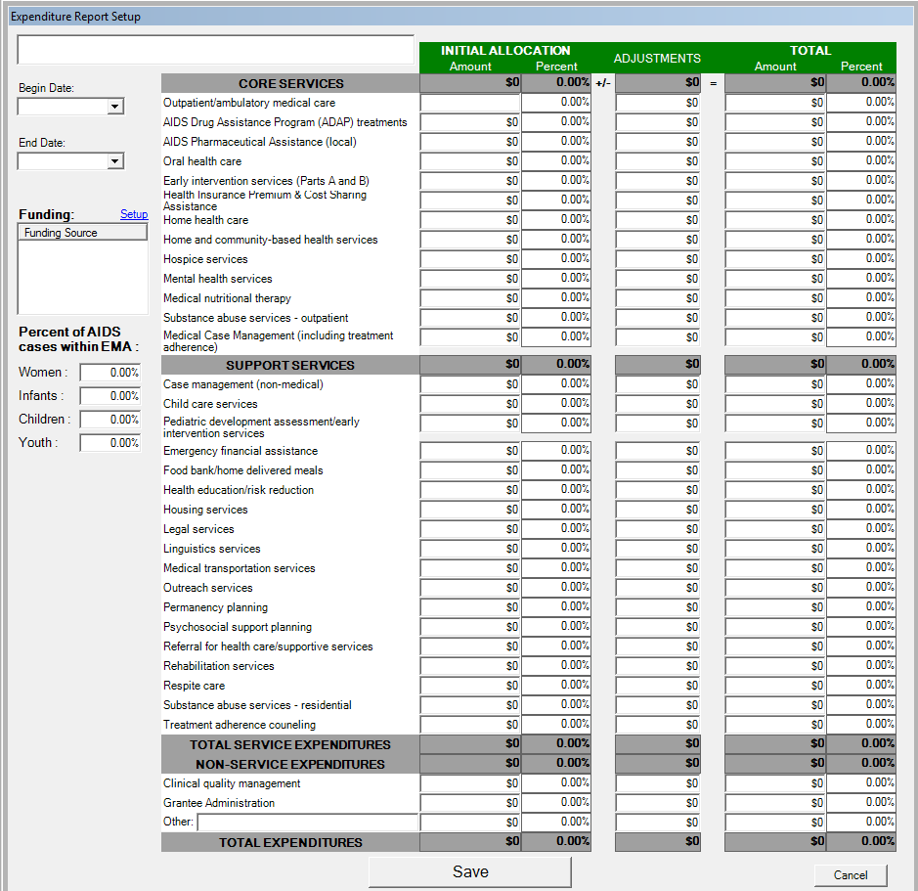

All of the data on this form is entered by the central user. This represents the amount of money that is allocated from the specified funding sources, and how much is initially intended for each service category. The Adjustments column is to account for adjustments that may be made in allocations over time.

Calculation values for the WICY report

Once the allocations are entered on this form, you can run a WICY Report. In order to populate the report, CAREWare uses a simple percentage calculation. For each service category, it calculates the percent of actual services (this is taken from the service data that is entered for all the clients) that are performed for each subgroup and multiplies that percent by the amount that is allocated for the service category to determine the final value for that field on the report.

For example:
$20,000 is allocated for Oral Health (this is entered on the Expenditure Report Setup and represents the total allocated for Oral health).

200 Oral Health services are entered into CAREWare in the given reporting period: 40 are to women, 10 to youths, and none given to children or infants (the majority of services are for clients not included in this report).

CAREWare would calculate that 20% of the total Oral Health services are for women (40/200) and 5% for youths (10/200). The WICY Report would show $4,000 as the amount spent on Women (.2*20,000), $1000 and the amount spent on Youths (.05*20,000), and 0 spent on Children and Infants.

