CAREWare has added an interface for data sharing called Provider By Provider Sharing. This feature can be accessed through the Administrative Options in the Central Administration domain.

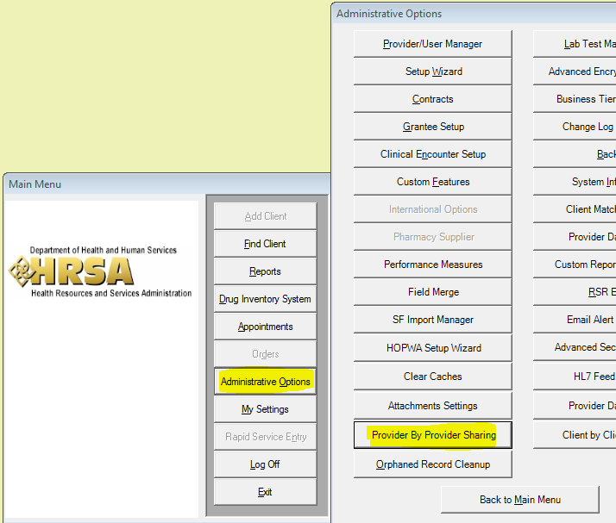

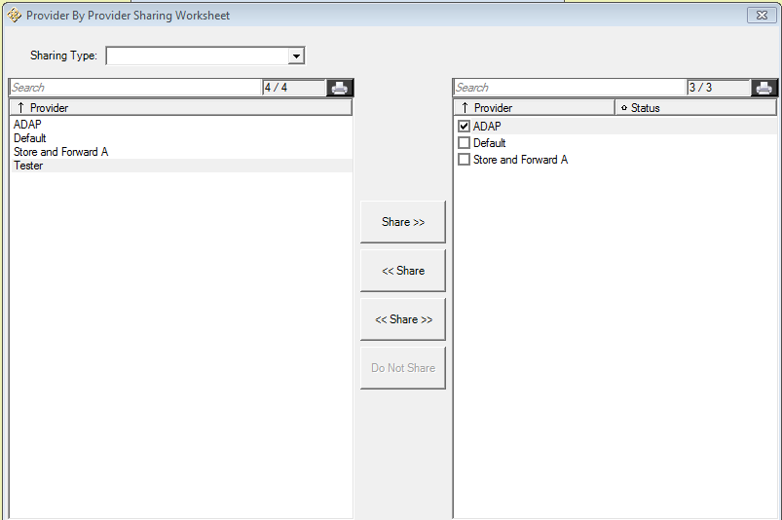

In the Provider By Provider Sharing Worksheet, a user has the option of choosing each domain to be shared, which domain they will share information with, and which way the sharing is set. A domain can share its’ information with another provider without receiving that providers information. The sharing type field is where you select which type of information to be shared between providers. The options are clinical, services, case notes, custom subform, and form designer. A sharing type must be chosen or an error will occur. The arrow next to the share button determines the direction information is sharing. The share button with arrows going both ways means that information is being sharing between both providers. Check boxes are used to determine which domains are selected. When you click a domain in the left provider options, the other domains show up in the list on the right provider options with check boxes. You can select one or more of the boxes at once to start sharing. Once a check box for a provider has been chosen, the share buttons will be available for choosing the sharing direction. The status on the right will have the arrow for the direction of sharing data for each of the sharing type options.

