CAREWare 5 User Guide for the:

Order Module

December 2014
Background:

Much of clinical care is practiced through someone ordering a procedure or test or service, and another person carrying it out. An example of this is a clinician requesting that a client receive a specific lab or screening test, or a vaccine, or perhaps that they schedule a session with an adherence counselor. This process is referred to as ordering.
Adding an order module to CAREWare will allow clinics to:
- Keep orders from falling through the cracks.
- Route orders to those that are responsible for carrying them out.
- Make it quicker to record the outcome of an order.
Starting with Business Tier build 316, CAREWare includes an Order Module. Users can create and track orders for Services and all Labs, Screening Labs, Screenings, and Immunizations. In addition, the order module allows for quick data entry once receipt of the service or lab result is obtained.

Where to start:

The Order Module (OM) can be accessed from the main menu or from within a client.

The order process within your facility will determine how you use this module. Let’s start within a client and say that this individual has come into your facility for a visit. At the close of the visit, the clinician goes directly into the client’s record and orders some tests.

The Order Module is accessed from the top of the client screen:

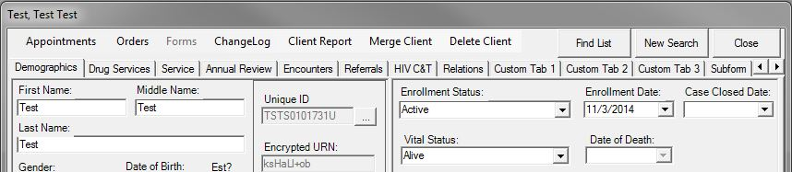

Select Orders. Let’s review the main features/functions numbered in the screen:

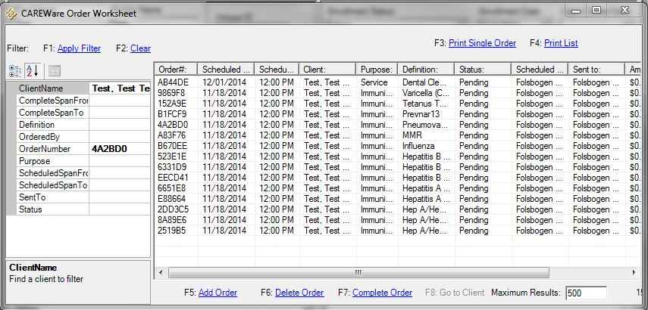
1
2
3
4
5
1. Properties: The items “Client Name” through “Status” are the properties that allow you to filter which client(s) and which order(s) appear. When you click on an item a short description will appear below.
2. Values: To select a value for a filter, you must click your mouse in the appropriate row in this column. That will cause either the ellipsis to appear (as it does here with Client Name) or a down arrow. We could filter orders for a specific client, or all orders for all clients between certain dates; or all orders made by a specific individual, or perhaps most importantly, by Order Status (Pending, Met or Missed).

3. Click Apply Filter, or press F1

4. Functions:
F5 to Add an Order; F6: Delete a selected Order; F7: Complete Order; F8: Go to Client.

- To create reports, either singly or as a List.

Now let’s create an order:
- Click “Add Order” or press F5.
- Enter the Date, Time, and Individual doing the ordering.
- The ‘Ordered By’ list is created in Administrative Options > Employee Setup.
- As you select an item on the left (Order Purpose), the list of possible items to order appear on the right (Definitions). The list will expand to the right as you select more categories. For example, here we’ve selected Immunizations, and then checked 2 items on the list (Hep B and Flu). Now let’s order some Labs. By clicking on Labs on the left, the list is now populated on the right (see below).
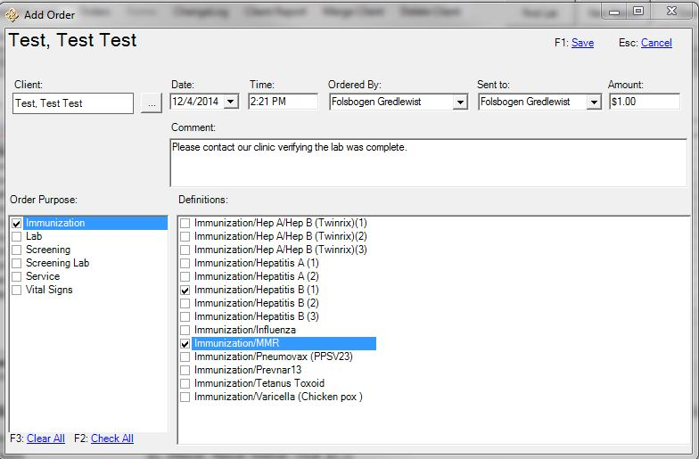

Adding Laboratories to the list…

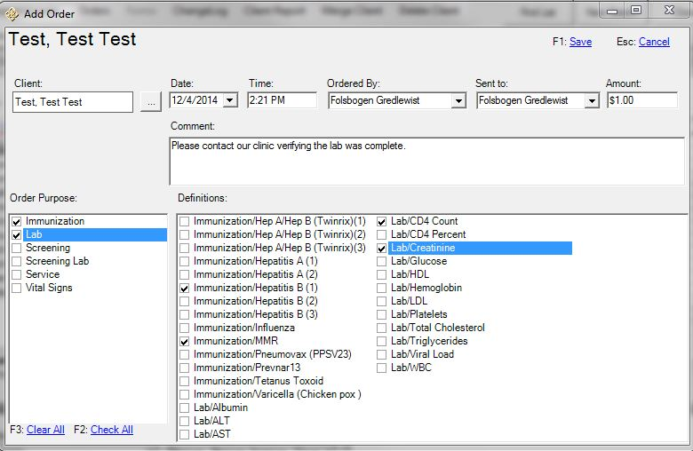

NOTE: As Items are added, you will likely need to scroll to the right to view all the choices!

Once you are done, click Save on the top (F1). Now each item has a Status of “Pending.”

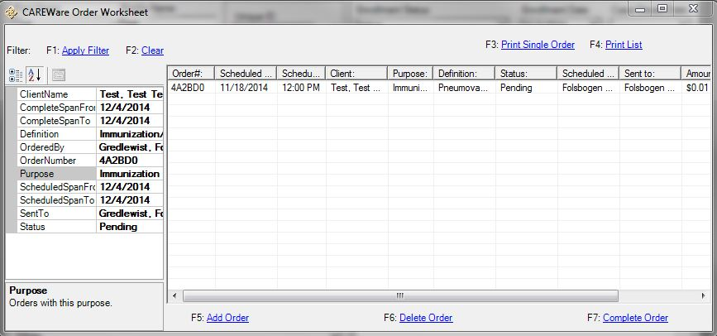

Completing Orders

Now let’s say that the Client Test, Test received his 2 vaccination shots, for Hep B and Flu. To complete these orders, and record that in CAREWare, select the order of interest and then F7 (Complete Order); CAREWare will take you directly to the screen of interest so that the order information can be entered.

- After we entered that the client received their first Hep B shot, that item is removed from the Pending list.
Below is a screen shot showing all Orders for this client (Pending and Met). We obtained this be removing the Pending Order status criteria on the left.

- Don’t forget: You must always select Apply Filter (F1) to show the results of your new criteria!

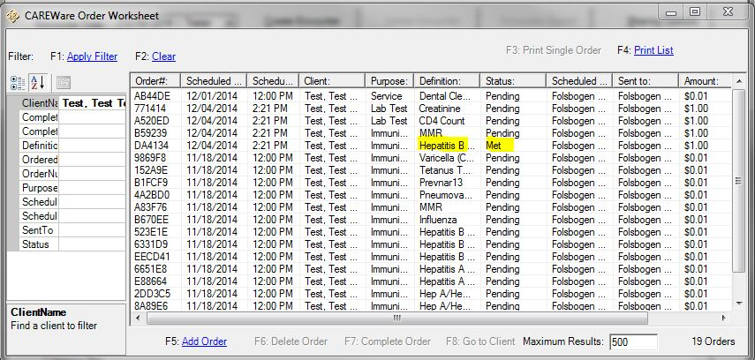

Here’s the Employee Setup screen in Administrative Options:

- We’re adding a new employee to the list. Select his/her functions and check if they are Active or not.

