How to run the CAREWare Diagnostic Utility

12/15/2014

Overview

The CAREWare Diagnostic Utility is able to monitor and time key activity internal to the CAREWare Server and to store that information in an XML file that can be sent to the jProg programmers for analysis related to performance issues.

Below are step-by-step instructions on how to perform diagnostics on your server and to send the results to jProg.

1. Start the Diagnostic Utility

- Log into the Central Administration domain
- Click Administrative Options
- Click Business Tier Diagnostics

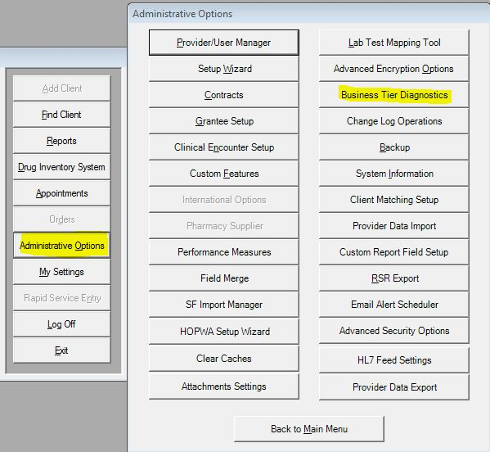

- Estimate the number of minutes you will need to re-produce the performance issue and enter that in the Number of Minutes field. Note that it is OK to over estimate the number of minutes by a few minutes, but you don’t want to make it too long, because it would create a very large diagnostic file.

- Click the Turn On button then click Close

Note: You can perform these same steps for the client tier as well at the same time.

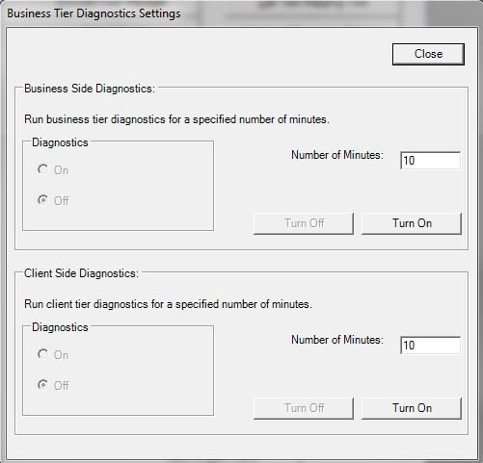

2. Do Some Stuff in CAREWare

You can now do the tasks that you want to run diagnostics for. It is OK to log out of the central provider and log in to a data entry provider. Once you have performed the tasks with the performance problems you can turn off the diagnostic utility.

3. Turn Off the Diagnostic Utility

- Log into the Central Administration domain
- Click Administrative Options
- Click Business Tier Diagnostics
- Click Turn Off for the business tier (and the client tier, if it’s on)

4. Zip the Diagnostic Output and Send To jProg

On the computer where the CAREWare Business Tier is installed, in the “C: Program Files\CAREWare\RW CAREWare Business Tier” in the folder labeled diagnostics. There will be a .TXT file with today’s date on it. Label the file as business tier or client tier, attach the diagnostics file to an email, and send it to cwhelp@jprog.com.

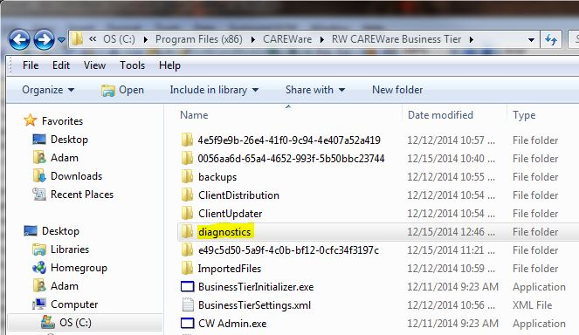

Viewing the Diagnostic Utility File (Optional)

In some cases non-jProg programmers may want to view the information in this file. If you want to view the diagnostic information you can do so through the CW Admin.exe utility (see the CAREWare FAQ for information on running that).

You can view the Diagnostics by following these steps:

- Open the business tier folder at C: Program Files\CAREWare\RW CAREWare Business Tier
- Right click CW Admin and click Run as administrator
- Click the Diagnostics tab
- Click the diagnostics file for the date you wish to review
- Click Show Diagnostics

