
Jeff Murray’s Programming Shop, Inc.

RW CAREWare 5

Client Level HOPWA Tracking and Reporting

Version 1.0

March 26, 2010

Copyright © 2002-2010 Jeff Murray's Programming Shop, Inc. (jProg). All rights reserved.

Client Level HOPWA Tracking and Reporting in CAREWare

Overview
This document used as a reference guide for the HOPWA feature in CAREWare 5. This will detail where the HOPWA feature is and how to use it. This feature includes the HOPWA contract, services, custom service fields, and a custom sub form that the user can enter in the household beneficiaries. There is also a HOPWA report section that the user can use to run the HOPWA reports to keep track of all HOPWA services entered through CAREWare.

User Permissions
In order to access the HOPWA feature, the user needs necessary permissions. You can enable HOPWA and run its reports in either the Central Administration domain or the Real Time Provider’s domain. Each will have their own permissions.

The first criterion that the user needs is to have access to the Central Administration domain and have administrative rights to grant permissions. The permission the user must enable is “Run Sponsored Custom Fields”. For the real time provider’s domain, the domain permission must be enabled prior to enabling it for the user. To enable or disable any permission in CAREWare, the user must log into Central Administration, click Administrative Options, and click on Provider User Manager. Once there, they can edit the permissions by right clicking and granting the permission for the user as shown below.

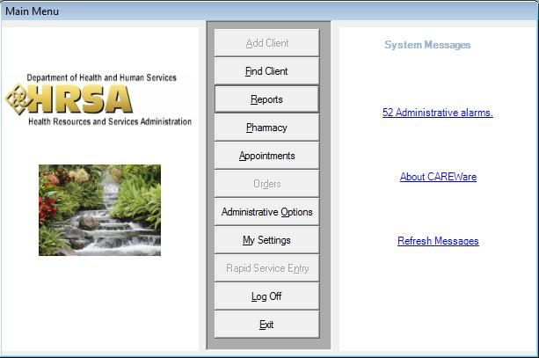

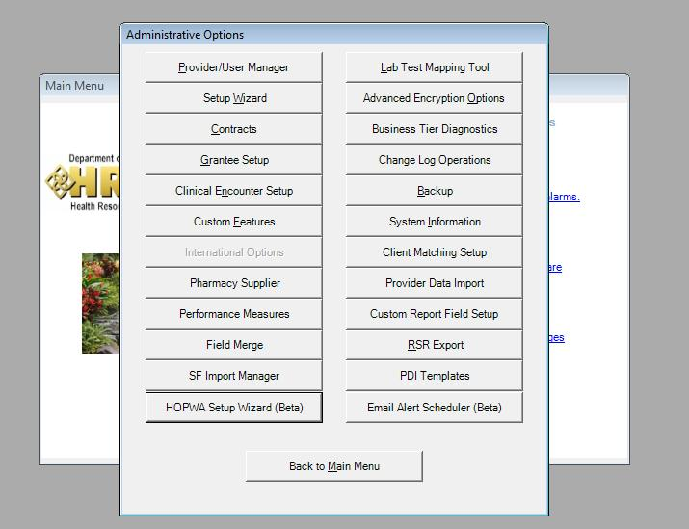

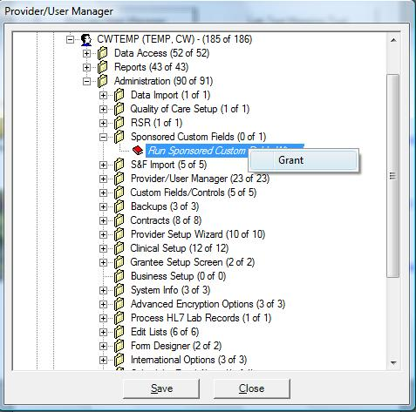

In order to have access to the HOPWA Reports, the user should enable the permission “Run HOPWA Reports” like shown below.

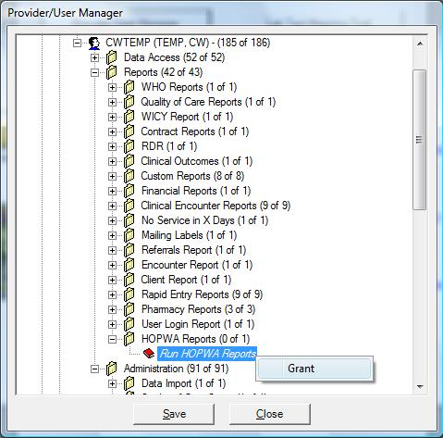

Enabling HOPWA
To enable HOPWA, you must log into the Central Administration domain or the domain you want to enable it for and enter the Administrative Options. Within there, there is a button labeled “HOPWA Setup Wizard”. If button is disabled, please refer to “Enable Permission” section above.

From here we can choose which provider we want to enable/disable HOPWA for once the button is clicked. For the real time provider’s domain, this form is skipped.

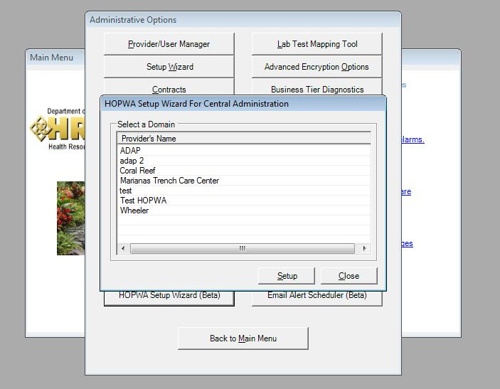

When you click the setup, you will access the enable/disable form for HOPWA.

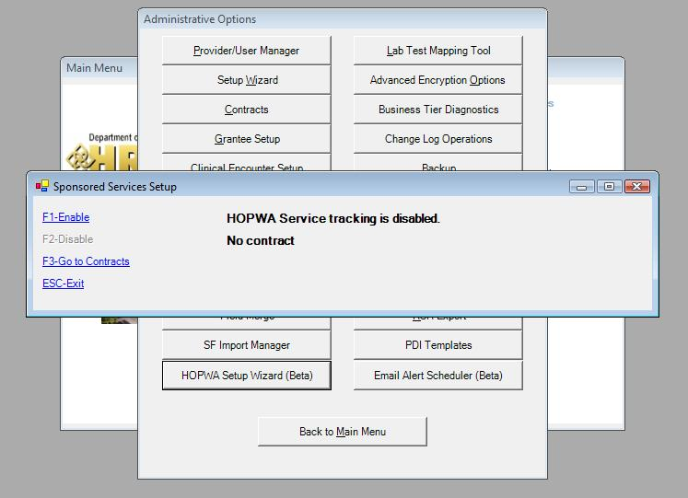

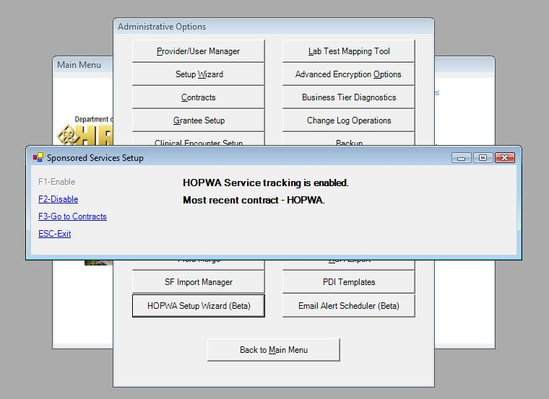

When HOPWA is enabled, CAREWare automatically creates a HOPWA contract, funding source, contract item, and all available pre-defined HOPWA services for that HOPWA contract. It also generates a custom subform labeled Household Beneficiaries.
Once HOPWA services are entered for clients, the user can not disable HOPWA until those services are deleted.

HOPWA Contract
The HOPWA contract, contract funding, and contract item are all labeled “HOPWA” when first created. The user can edit the contract name and contract item name, but not the funding source. There will not be a contract date span for this contract as well. Users can enter in a date span and/or create another HOPWA contract with a date span. The HOPWA sub services are made from the Non Care Act services service category.

The pre-defined HOPWA services are:

- H STRMU Enrollment
- H STRMU Update
- H STRMU Exit
- H TBRA Enrollment
- H TBRA Update
- H TBRA Exit
- H Permanent Facility Enrollment
- H Permanent Facility Update
- H Permanent Facility Exit
- H Transitional Facility Enrollment
- H Transitional Facility Update
- H Transitional Facility Exit
- H CF Permanent Facility Enrollment
- H CF Permanent Facility Exit

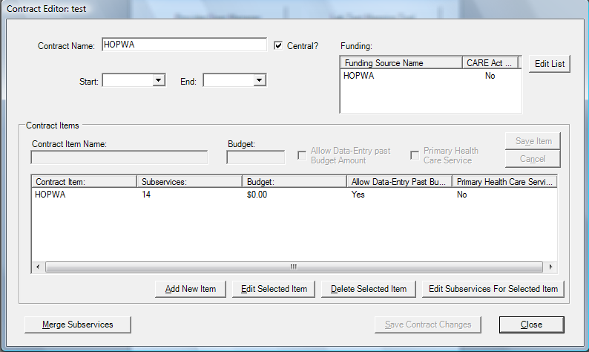

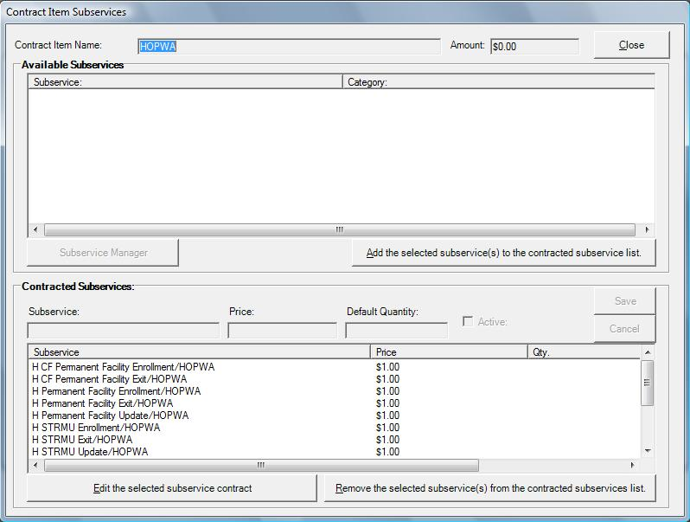

HOPWA Contract Rules
For any user that wants to edit the HOPWA contract. There are a few rules that CAREWare enforces when dealing with this contract. The user is very limited on what they can edit. HOPWA contracts can only have HOPWA funding and HOPWA services. Users can neither add other funding sources nor add HOPWA services to any contract with other funding sources. HOPWA funding sources can not be deleted or edited. Generally, users can only remove a service from the HOPWA contract, add/edit the date span, edit the contract name, edit the contract item name, and edit the default quantity and price of the service.

Household Beneficiaries Subform
As part of HOPWA, there needs to be a form that the user can enter in the HOPWA client’s beneficiaries. In order to add these records, a custom subform is created when HOPWA is enabled. The subform is labeled “Household Beneficiaries”. In this form, the user can add the client’s beneficiaries name, race, ethnicity, and any notes, along with the entry date. This can only be done on the real time provider’s domain.

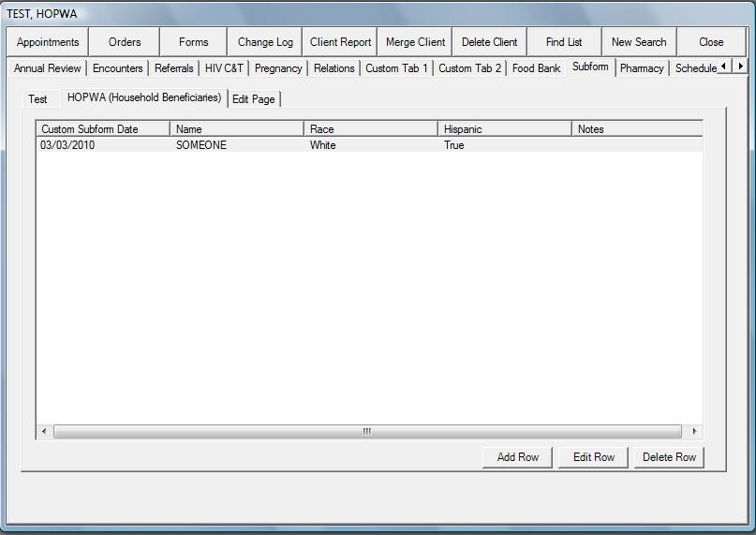

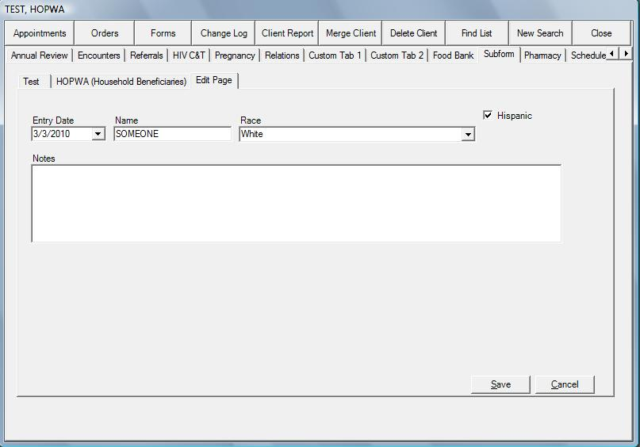

Adding HOPWA Services
Adding HOPWA services uses the same methodology as adding any service in CAREWare. The user selects the client with the client find feature in CAREWare and then selects the Service Tab. The user may want to have certain HOPWA services precede others. For instance, the user may want to add an Enrollment service first, then an update service, then exit. Each service has its own custom controls.

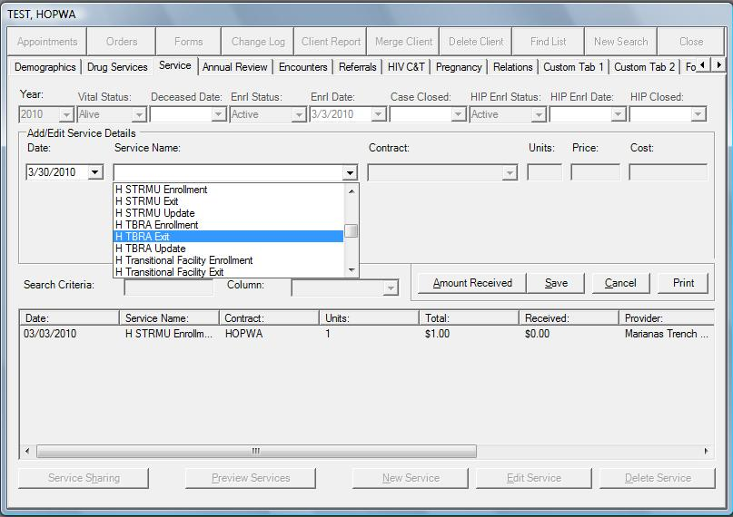

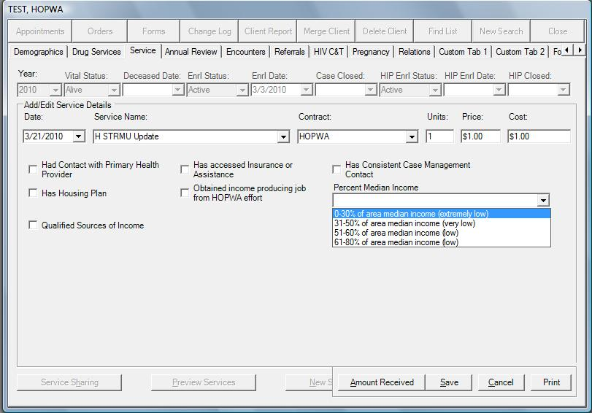

HOPWA Reports
To be able to get to the HOPWA Reports, the user needs to select the Report button from the Main Menu.

Once clicked, the report menu will be available with the HOPWA Reports button. If the HOPWA Reports button is disabled, please refer to the “User Permission” section above.

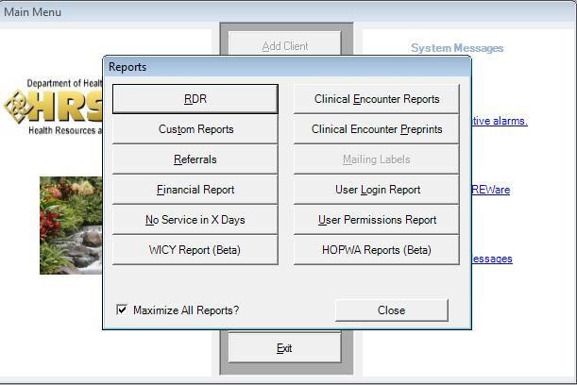

Once selected, the user will get a chance to enter in the date span, the report, as well as the domain. The HOPWA reports can run across multiple domains in Central Administration.

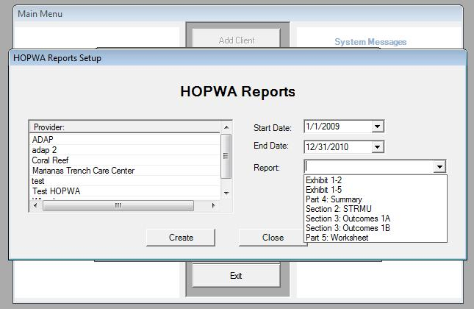

HOPWA Report Breakdown

Exhibit 1-2
Activity – Name of the HOPWA service
- Short Term Housing Assistance (STRMU)
- Tenant Based Rental Assistance (TBRA)
- Case Management
- Health/medical/intensive care services
Actual
- Short Term Housing Assistance (STRMU) - Unduplicated count of patients who received an H STRMU Enrollment, Update and/or Exit service within the specified date range.
- Tenant Based Rental Assistance (TBRA) – Unduplicated count of patients who received an H TBRA Enrollment, Update and/or Exit service within the specified date range.
- Case Management – Unduplicated count of individuals who have ever received any HOPWA service and received any Non HOPWA service within the specified date range.
- Health/medical/intensive care services – Unduplicated count of individuals who ever received any HOPWA service and has an Ambulatory Outpatient service within the date range.

Expended
- Short Term Housing Assistance (STRMU) - Sum of the total field for any STRMU service within date range.
- Tenant Based Rental Assistance (TBRA) – Sum of total field for any TBRA service within date range.
- Case Management – Not calculated in CAREWare
- Health/medical/intensive care services – Not calculated in CAREWare

Total HOPWA
Sum of both STRMU and TBRA expended.

Exhibit 1-5
Receiving Housing Assistance
- Persons with HIV/AIDS – Unduplicated count of clients who received 1 or more HOPWA services in the given period.
- Other Family Members – Unduplicated count of Household beneficiaries for clients that received 1 or more HOPWA services in the given period.
- Race and Ethnicity – Count sorted by race and ethnicity
Receiving supportive services with Housing Assistance
- Persons with HIV/AIDS – Unduplicated count of clients who received 1 or more HOPWA services in the given period and at least one of the services had “Has Consistent Case Management” checked.
- Other Family Members – Unduplicated count of Household beneficiaries for clients that received 1 or more HOPWA services in the given period and at least one of the services had “Has Consistent Case Management” checked.
- Race and Ethnicity – NA
Receiving supportive services only
- Persons with HIV/AIDS – Unduplicated count of clients who received 1 or more HOPWA services in the given period and any non HOPWA service within date span.
- Other Family Members – Unduplicated count of Household beneficiaries for clients that received 1 or more HOPWA services in the given period and any non HOPWA service within date span.
- Race and Ethnicity – NA

Part 4: Summary of Performance Outcomes
Permanent Housing Assistance
Total Number of Households Receiving Housing Assistance
    - Tenant-Based Rental Assistance – Unduplicated count of clients who had an H TBRA service in the selected time period.
    - Permanent Supportive Housing Facilities/Units (Facility Based Housing Operations) – Unduplicated count of clients who had an H Permanent Facility service on or before the date span.
Assessment: Number of Households continuing with this housing (per plan of expectation for next year)
    - Tenant-Based Rental Assistance – Unduplicated count of clients who had an H TBRA enrollment or update service in the selected time period and have not yet exited.
    - Permanent Supportive Housing Facilities/Units (Facility Based Housing Operations) – Unduplicated count of clients who had an H Permanent Facility enrollment or update service on or before the time period and have not yet exited.
Assessment: Number of Exited Households and Housing Status
    - Tenant-Based Rental Assistance – Unduplicated count of each Exit Outcome value for Permanent Facility Exit services in date range.
    - Permanent Supportive Housing Facilities/Units (Facility Based Housing Operations) – Unduplicated count of each Exit Outcome value for Permanent Facility Exit services within the date range.

Transitional Housing Assistance
Total Number of Households Receiving Housing Assistance
    - Transitional/Short-Term Supportive Facilities/Units – Unduplicated count of clients who had H Transitional Facility service within the date span.

Of the Number of Households Receiving Housing Assistance this Operating Year
Total number of households that will continue in residences:
      - Transitional/Short-Term Supportive Facilities/Units – Unduplicated count of clients enrolling or exiting the H Transitional Facility enrollment or update service on or before the date span and have not had an H Transitional Facility Exit service in the date span.
Total number of households whose tenure exceeded 24 months:
      - Transitional/Short-Term Supportive Facilities/Units – Unduplicated count of clients enrolling or exiting the H Transitional Facility enrollment or update service 24 months prior to the date span and have not had an H Transitional Facility Exit service in the date span.
Assessment: Number of Exited Households and Housing Status
    - Transitional/Short-Term Supportive Facilities/Units – Unduplicated count of each Exit Outcome value for H Transitional Facility Exit service in date range.

Section 2 Prevention of Homelessness
STRMU Housing Assistance – Unduplicated count of clients who had an H STRMU service within the date span
Assessment of Housing Status – A count of each Exit Outcome value for H STRMU Exit
HOPWA Client Outcomes
Stable/Permanent Housing (PH)
  - Private Housing w/o subsidy
  - Other Private Housing w/o subsidy
  - Other HOPWA support (PH)
  - Institution
Temporary Stable, with Reduced Risk of Homelessness
  - Current housing arrangements more STRMU
  - Transitional facility/Short-Term
  - Temporary/non-permanent
Unstable Arrangements
  - Emergency Shelter/streets
  - Incarcerated
  - Disconnected
Life Event
  - Deceased

1a – Unduplicated count of clients that received H STRMU service in previous 365 days from the begin date
1b – Unduplicated count of clients that received H STRMU service in previous 730 days from the begin date

Section 3 HOPWA Outcomes on Access to Care and Support
Categories of Service Accessed
- Of those counted in Exhibit 1-5, Persons with HIV/AIDS, did they have at least 1 enrollment or update service indicating that they have a housing plan.
- Of those counted in Exhibit 1-5, Persons with HIV/AIDS, did they have at least 1 enrollment or update service indicating that they have a consistent case management.
- Of those counted in Exhibit 1-5, Persons with HIV/AIDS, did they have at least 1 enrollment or update service indicating that they have had contact with a primary health provider.
- Of those counted in Exhibit 1-5, Persons with HIV/AIDS, did they have at least 1 enrollment or update service indicating that they have had accessed insurance or assistance.
- Of those counted in Exhibit 1-5, Persons with HIV/AIDS, did they have at least 1 enrollment or update service indicating that they have had have qualified sources of income.
- Of those counted in Exhibit 1-5, Persons with HIV/AIDS, did they have at least 1 enrollment or update service indicating that they have had obtained employment.

Part 5: Worksheet – Determining Housing Stability Outcomes
This report shows the summary of Part 4 and Section 2.
Permanent Housing Assistance
Stable Housing
Exit Outcomes of 3, 4, 5 or 6.
3 – Private Housing
4 – Other HOPWA- funded service (not STRMU)
5 – Other subsidy
6 - Institution
Temporary Housing
Exit Outcomes of value 2
2 – Temporary Housing
Unstable Arrangements
Exit Outcomes of 1, 7, or 8
1 – Emergency Shelter
7 – Incarcerated
8 – Disconnected/Unknown
Life Event
Exit Outcome of 9
9 – Deceased
Reduced Risk of Homelessness: Short Term Assistance
Stable Housing
1 – Private Housing w/o subsidy
2 – Other private housing w/o subsidy
3 – Other HOPWA support (PH)
4 – Other housing subsidy (PH)
5 - Institution
Temporary Housing
6 - Current housing arrangements more STRMU
7 – Transitional Facility/Short Term
8 - Temporary/non-permanent
Unstable Arrangements
9 – Emergency Shelter/Streets
10 – Incarcerated
11 – Disconnected
Life Event
9 – Deceased

